PortSwigger Web Security Academy — Proof of Concept

NoSQL Injection Lab 1

Detecting NoSQL injection
Category | NoSQL Injection
Lab | Lab 1
Completed By | Security Researcher
Platform | PortSwigger Web Security Academy

Lab Objective
Exploit NoSQL injection in a product category filter to reveal hidden products.

Step-by-Step Exploitation
- In Burp's browser, access the lab and click on a product category filter.
- In Burp, go to Proxy > HTTP history. Right-click the category filter request and select Send to Repeater.
- In Repeater, submit a ' character in the category parameter. Notice that this causes a JavaScript syntax error. This may indicate that the user input was not filtered or sanitized correctly.
- Submit a valid JavaScript payload in the value of the category query parameter. You could use the following payload:
- Gifts'+'
- Make sure to URL-encode the payload by highlighting it and using the Ctrl-U hotkey. Notice that it doesn't cause a syntax error. This indicates that a form of server-side injection may be occurring.
- Identify whether you can inject boolean conditions to change the response:
- Insert a false condition in the category parameter. For example:
- Gifts' && 0 && 'x
- Make sure to URL-encode the payload. Notice that no products are retrieved.
- Insert a true condition in the category parameter. For example:
- Gifts' && 1 && 'x
- Make sure to URL-encode the payload. Notice that products in the Gifts category are retrieved.
- Submit a boolean condition that always evaluates to true in the category parameter. For example:
- Gifts'||1||'
- Right-click the response and select Show response in browser.
- Copy the URL and load it in Burp's browser. Verify that the response now contains unreleased products. The lab is solved.
- Community solutions
- Popo Hack

Screenshots & Evidence
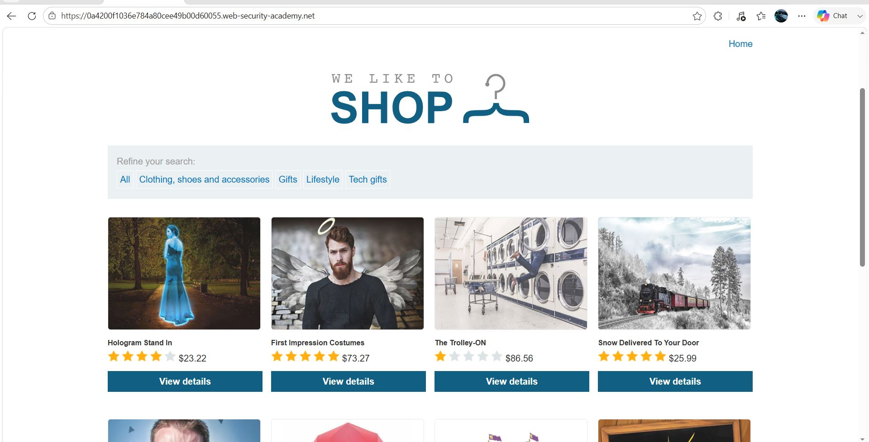
Figure 1: 1
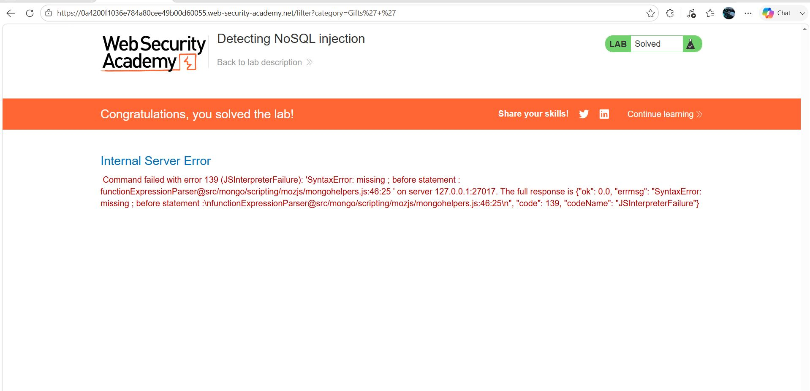
Figure 2: 2
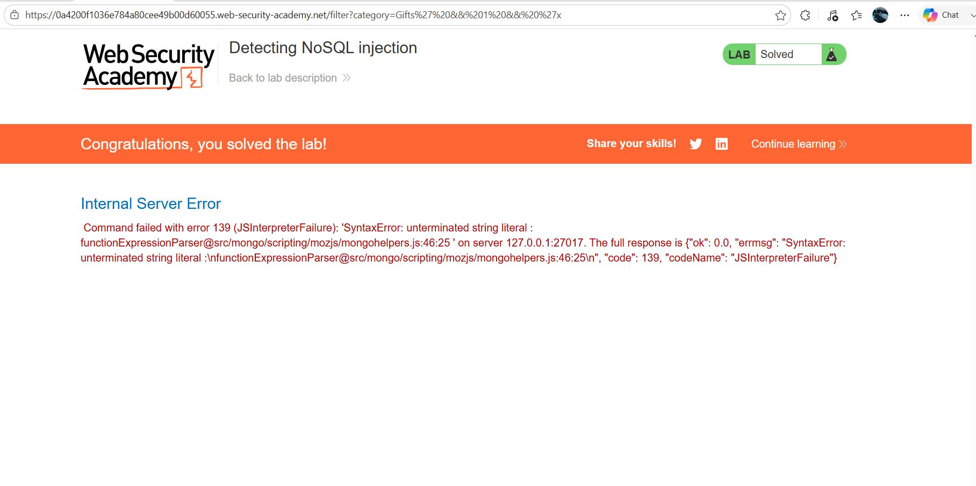
Figure 3: 3
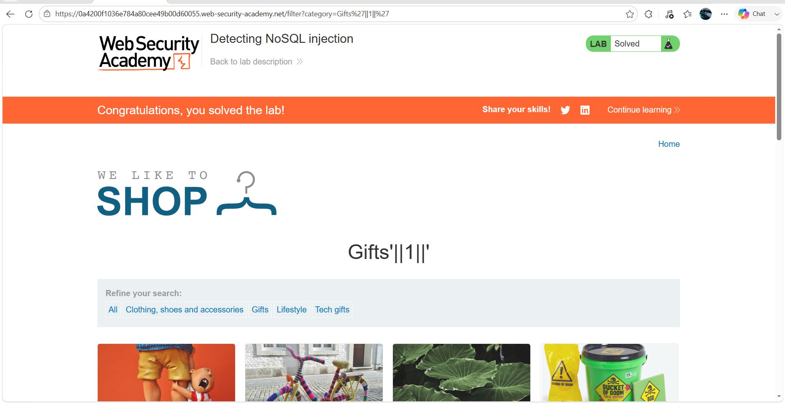
Figure 4: 4

Lab Status: SOLVED

